Các câu lệnh SQL

# Đổi tiếng việt thành tiếng anh

Ta viết hàm chuyển đổi

CREATE FUNCTION convertUnicodetoASCII (@text nvarchar(max))

RETURNS nvarchar(max)

AS

BEGIN

SET @text = LOWER(@text)

DECLARE @textLen int = LEN(@text)

IF @textLen > 0

BEGIN

DECLARE @index int = 1

DECLARE @lPos int

DECLARE @SIGN_CHARS nvarchar(100) = N'ăâđêôơưàảãạáằẳẵặắầẩẫậấèẻẽẹéềểễệếìỉĩịíòỏõọóồổỗộốờởỡợớùủũụúừửữựứỳỷỹỵýđð'

DECLARE @UNSIGN_CHARS varchar(100) = 'aadeoouaaaaaaaaaaaaaaaeeeeeeeeeeiiiiiooooooooooooooouuuuuuuuuuyyyyydd'

WHILE @index <= @textLen

BEGIN

SET @lPos = CHARINDEX(SUBSTRING(@text,@index,1),@SIGN_CHARS)

IF @lPos > 0

BEGIN

SET @text = STUFF(@text,@index,1,SUBSTRING(@UNSIGN_CHARS,@lPos,1))

END

SET @index = @index + 1

END

END

RETURN @text

END

SELECT dbo.DanhSachIP.SoThe, DanhSachIP.HoTen, **convertUnicodetoASCII (HoTen)** AS tennv_khongdau, IP FROM dbo.DanhSachIP

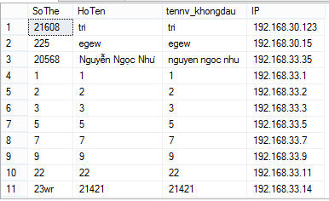

- Bây giờ, mình sẽ tìm kiếm dữ liệu không dấu hoặc có dấu chúng ta sử dụng câu lệnh sau:

DECLARE @query NVARCHAR(100)

SET @query = N'nguyen thao'

SELECT manv, tennv, **convertUnicodetoASCII(tennv)** AS tennv_khongdau, ngaysinh, tinhtrang, diachi1

FROM dbo.view_nhanvien

WHERE **convertUnicodetoASCII(tennv)** LIKE @query OR tennv LIKE @query

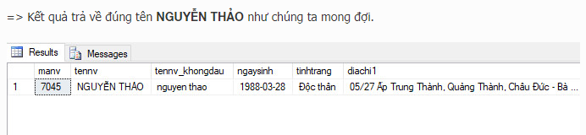

# Tài liệu tham khảo

<https://laptrinhvb.net/bai-viet/chuyen-de-csharp/--SQLSERVER---Huong-dan-cach-tim-tieng-viet-khong-dau/b3613b14f40a4a01.html>

CREATE FUNCTION [dbo].[non_unicode_convert](@inputVar NVARCHAR(MAX) )

RETURNS NVARCHAR(MAX)

AS

BEGIN

IF (@inputVar IS NULL OR @inputVar = '') RETURN ''

DECLARE @RT NVARCHAR(MAX)

DECLARE @SIGN_CHARS NCHAR(256)

DECLARE @UNSIGN_CHARS NCHAR (256)

SET @SIGN_CHARS = N'ăâđêôơưàảãạáằẳẵặắầẩẫậấèẻẽẹéềểễệếìỉĩịíòỏõọóồổỗộốờởỡợớùủũụúừửữựứỳỷỹỵýĂÂĐÊÔƠƯÀẢÃẠÁẰẲẴẶẮẦẨẪẬẤÈẺẼẸÉỀỂỄỆẾÌỈĨỊÍÒỎÕỌÓỒỔỖỘỐỜỞỠỢỚÙỦŨỤÚỪỬỮỰỨỲỶỸỴÝ' + NCHAR(272) + NCHAR(208)

SET @UNSIGN_CHARS = N'aadeoouaaaaaaaaaaaaaaaeeeeeeeeeeiiiiiooooooooooooooouuuuuuuuuuyyyyyAADEOOUAAAAAAAAAAAAAAAEEEEEEEEEEIIIIIOOOOOOOOOOOOOOOUUUUUUUUUUYYYYYDD'

DECLARE @COUNTER int

DECLARE @COUNTER1 int

SET @COUNTER = 1

WHILE (@COUNTER <= LEN(@inputVar))

BEGIN

SET @COUNTER1 = 1

WHILE (@COUNTER1 <= LEN(@SIGN_CHARS) + 1)

BEGIN

IF UNICODE(SUBSTRING(@SIGN_CHARS, @COUNTER1,1)) = UNICODE(SUBSTRING(@inputVar,@COUNTER ,1))

BEGIN

IF @COUNTER = 1

SET @inputVar = SUBSTRING(@UNSIGN_CHARS, @COUNTER1,1) + SUBSTRING(@inputVar, @COUNTER+1,LEN(@inputVar)-1)

ELSE

SET @inputVar = SUBSTRING(@inputVar, 1, @COUNTER-1) +SUBSTRING(@UNSIGN_CHARS, @COUNTER1,1) + SUBSTRING(@inputVar, @COUNTER+1,LEN(@inputVar)- @COUNTER)

BREAK

END

SET @COUNTER1 = @COUNTER1 +1

END

SET @COUNTER = @COUNTER +1

END

-- SET @inputVar = replace(@inputVar,' ','-')

RETURN @inputVar

END